**=============**

**Working with Obj-Open:**

**Obj-Open Purpose is to fetch single record based on class key:**

**Ex: Customer Table:**

**CustID: C1 ( Request Property)**

**Response Properties:**

**CustID**

**FName**

**LName**

**Age**

**City**

**---**

**Page-Copy :**

**This method is used to Copy Data From One Page to Other Page. It copies entire data from source page to target page. This method should be used when source and target page refers to Same Class.**

**Req: Implement Customer Search Functionality based on CustID:**

**- If customer is available display results in the same screen in read only format**

**Use Existing Customer Table & Make Sure Records are there in the CustTable:**

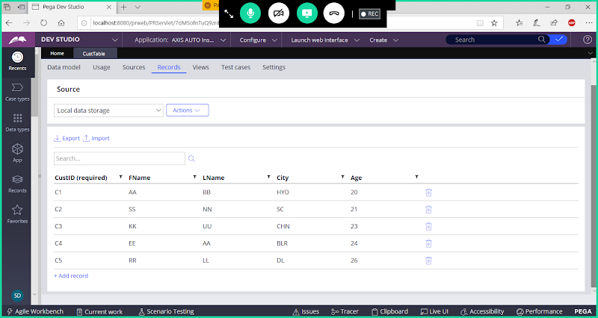

**Create a Page Property referring to Customer Table Class:**

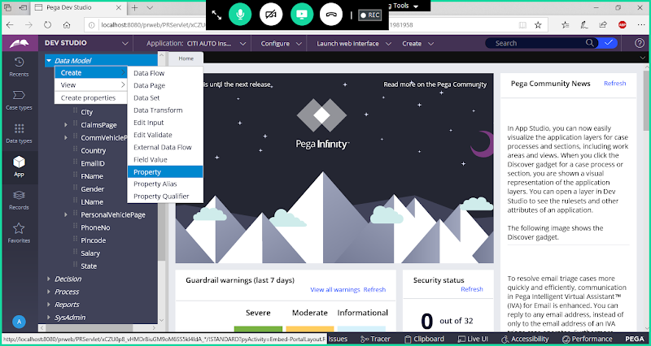

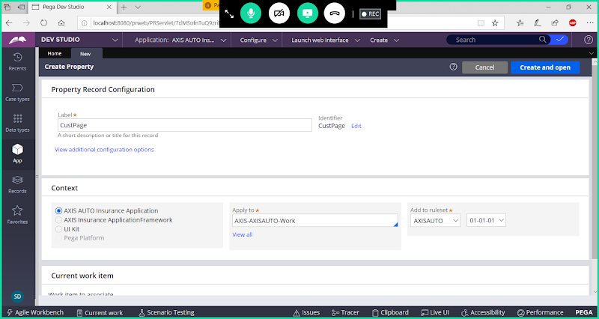

**Open**

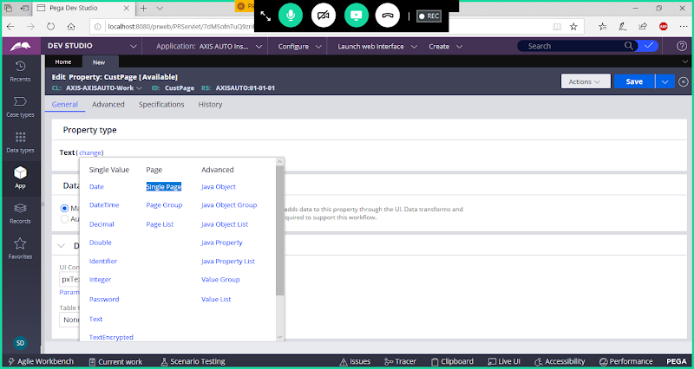

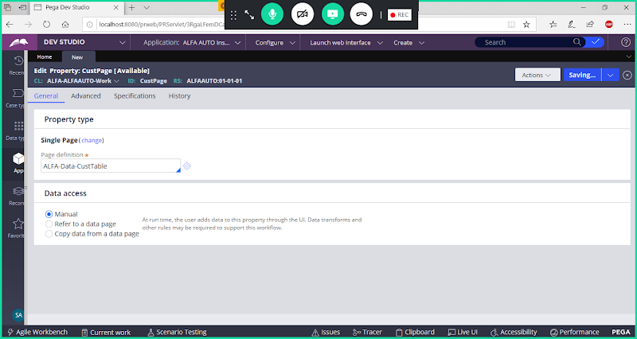

**Save Property**

**Create sections:**

**Section1: Create Section for Adding Customer Input (CustID):**

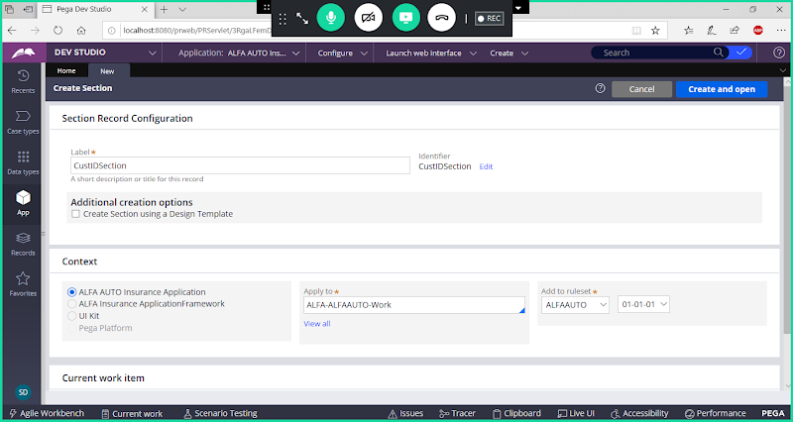

**Set Layout Format (Inline Grid Double) & Add Title, Now Add Control ( Text Input) & Map Property Name**

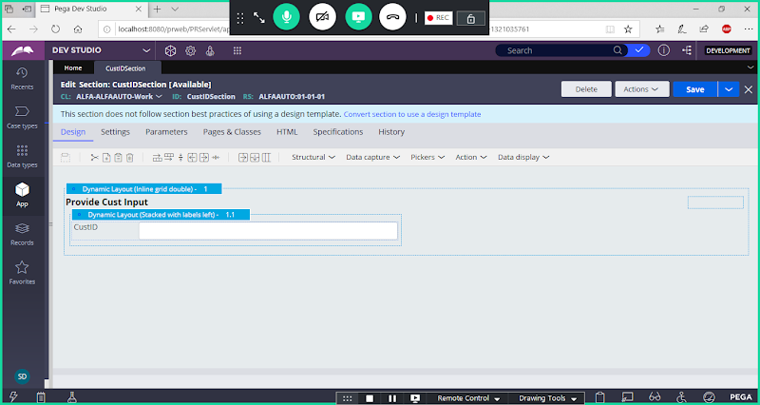

**Save section**

**Section2: Create Cust Results section:**

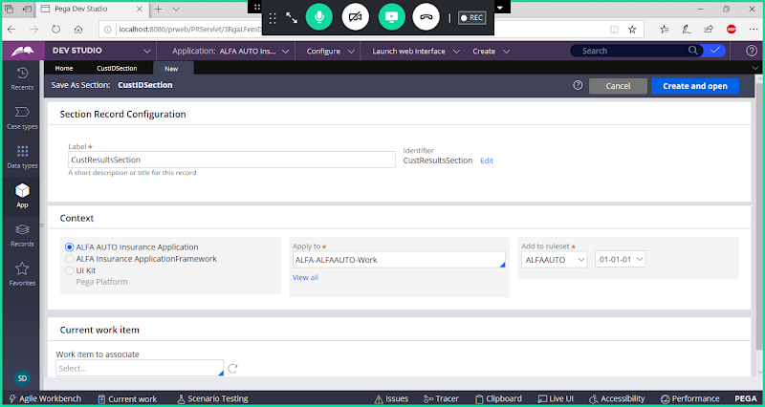

**Open & Map Results Properties ( Result Properties map from CustPage)**

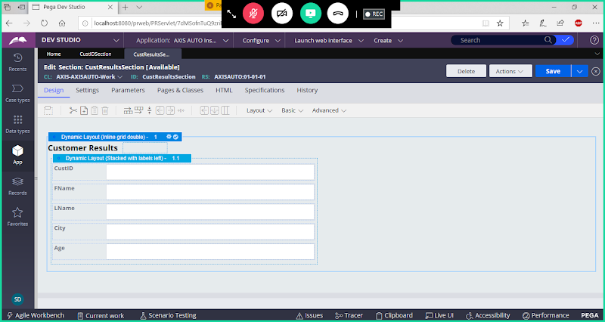

**Save section**

**Section 3: CustSearchSection**

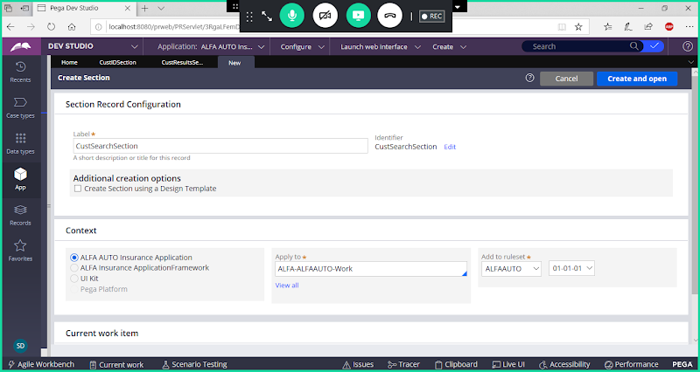

**Drag & Drop CustID Section & Cust Results Section  in Cust Search Section & In B/w Sections Add Button Control**

**Now Drag & Drop Sections & Add Button Control**

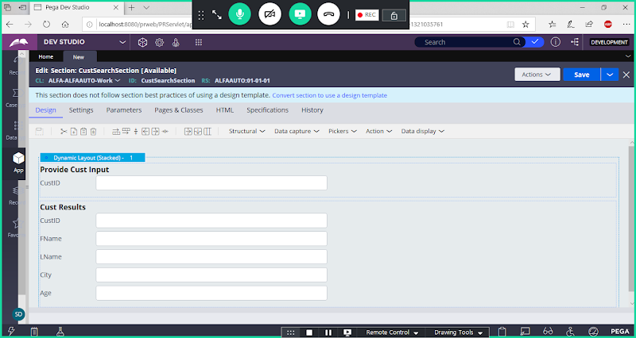

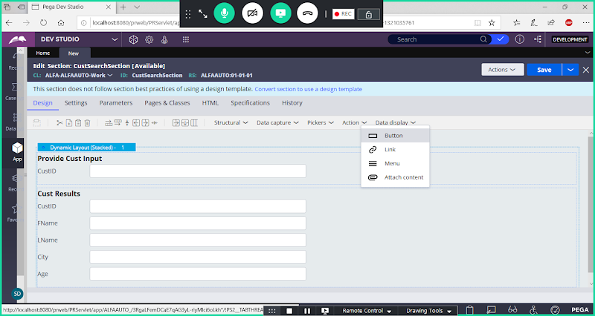

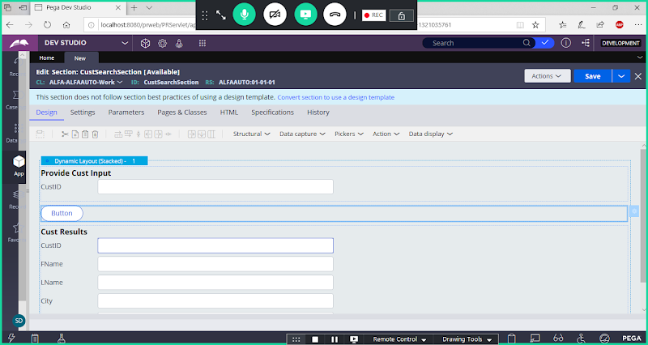

**Add Label for Button ( Search)-> Open Button Settings**

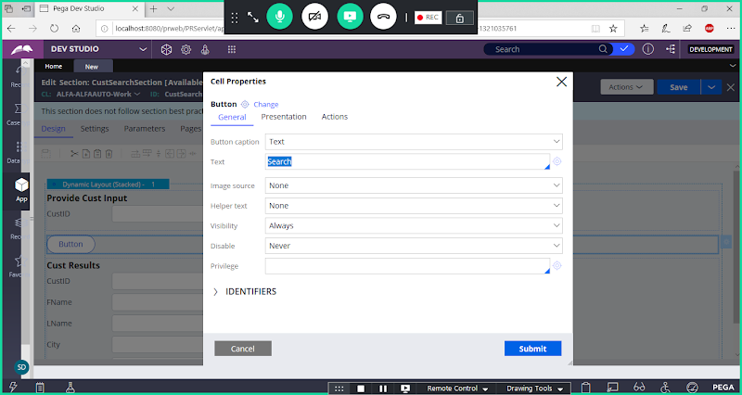

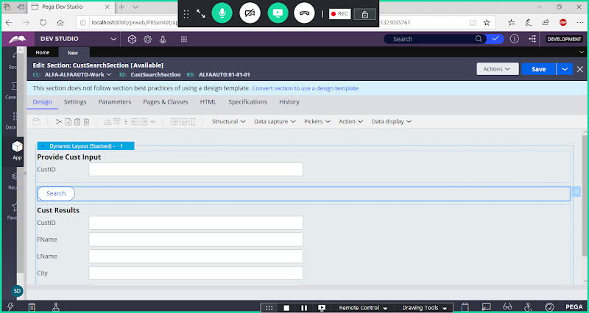

**Make Customer Results Section as Read Only**

**Double click on CustResults Panel Settings**

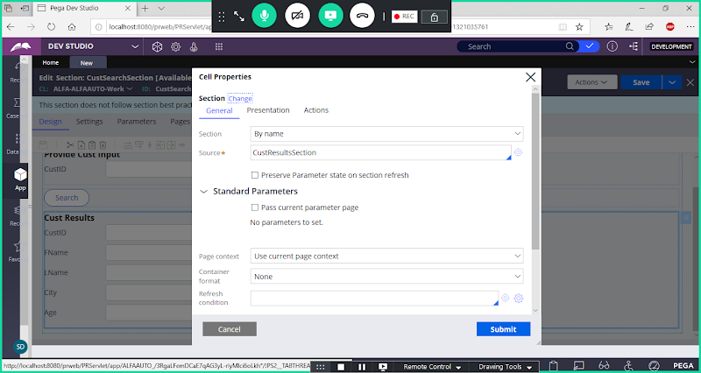

**Go to Presentation Tab:**

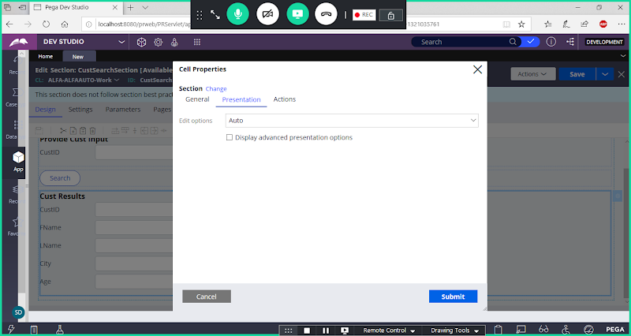

**Under Edit options select-> read Only always**

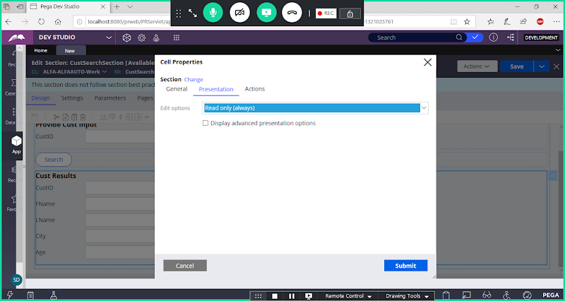

**Submit**

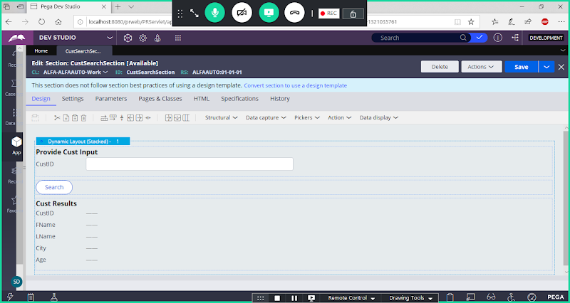

**Save section**

**Create A Flowaction for Cust Search section:**

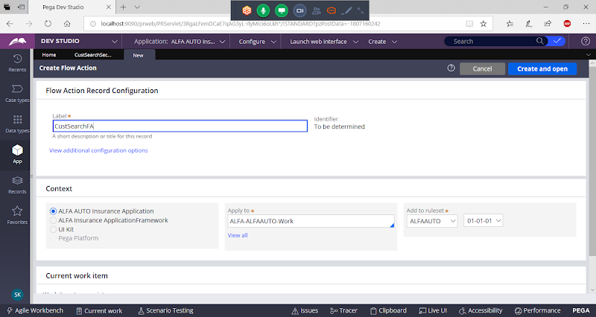

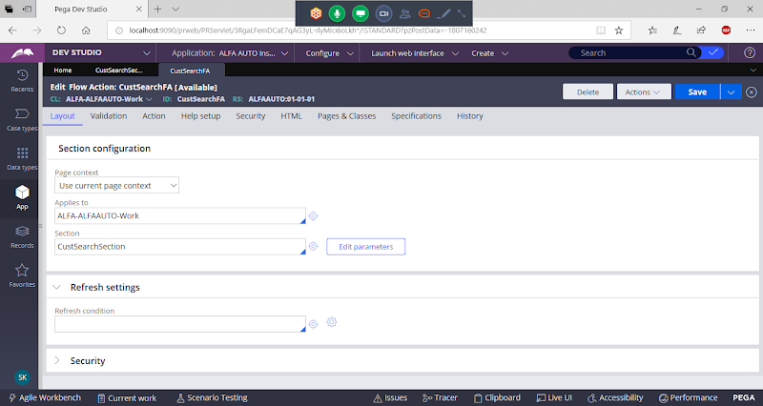

**Save Flowaction**

**Create Activity:**

**Technical-> Activity**

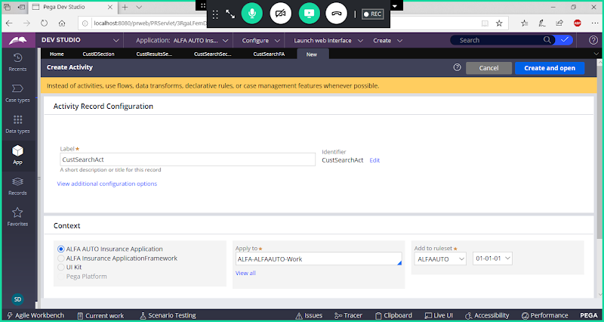

**Go to Pages & Classes**

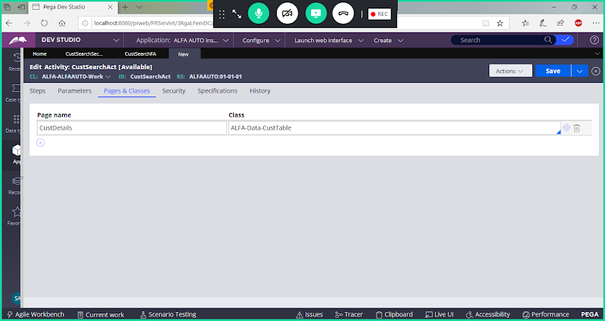

**Go to steps Tab:**

**Add Page New & Map Properties under Obj-Open**

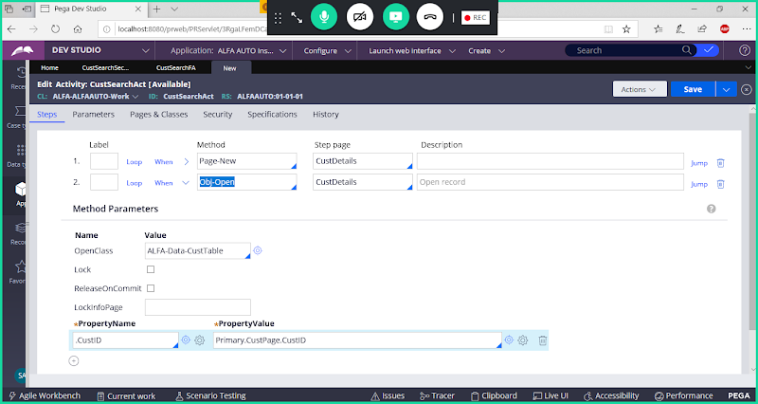

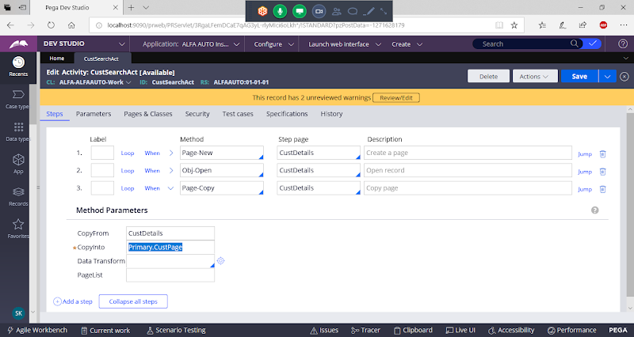

**Save activity**

**=====**

**Call this Activity on click on button in Cust Search section:**

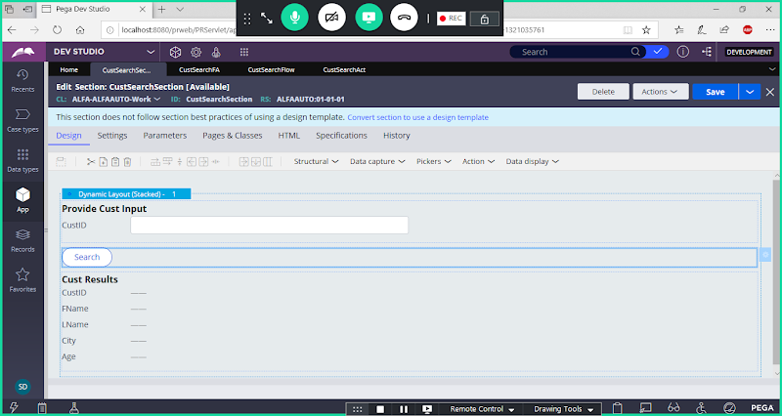

**Double Click on Button settings**

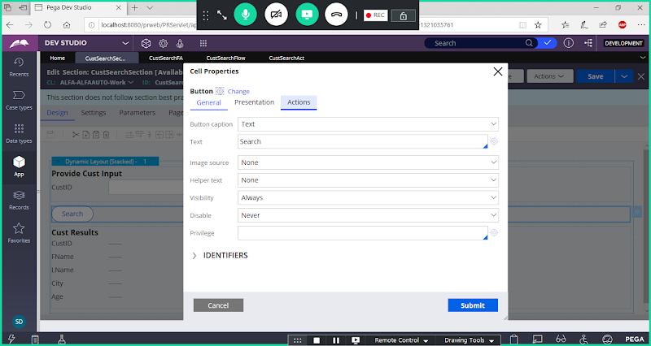

**Go to Actions Tab:**

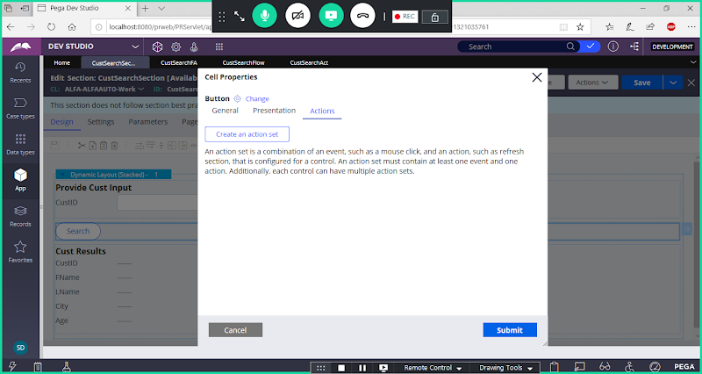

**Configure Action set**

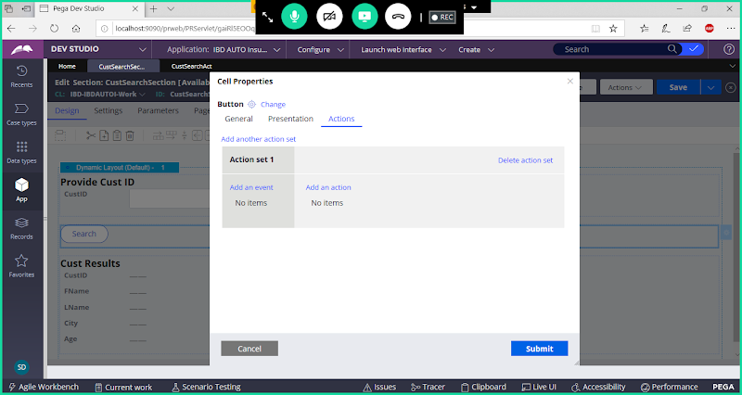

**Event Type: Click**

**Action Name: Display Refresh**

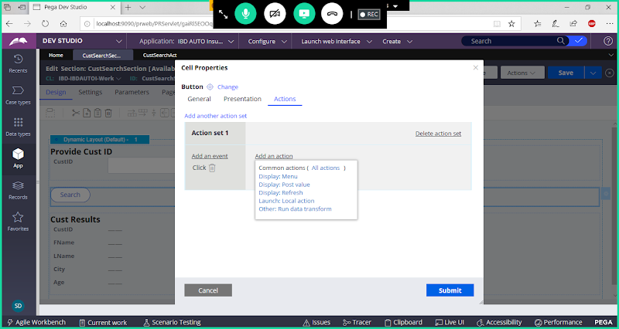

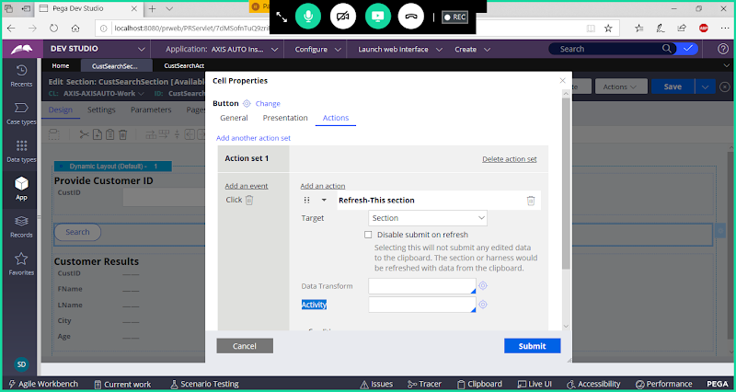

**Give Activity Name**

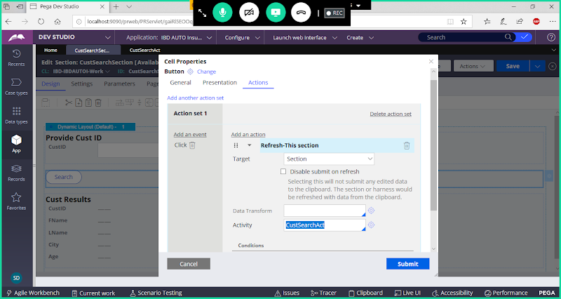

**Submit**

**Save section**

**Create a New Flow**

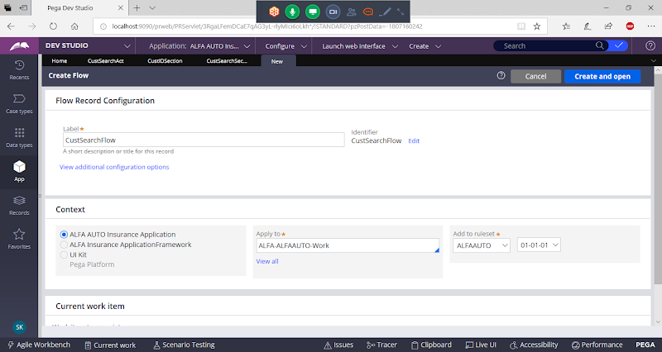

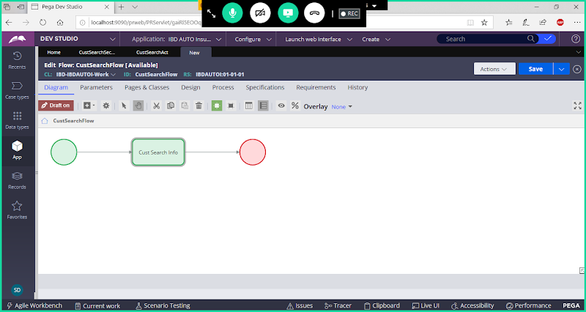

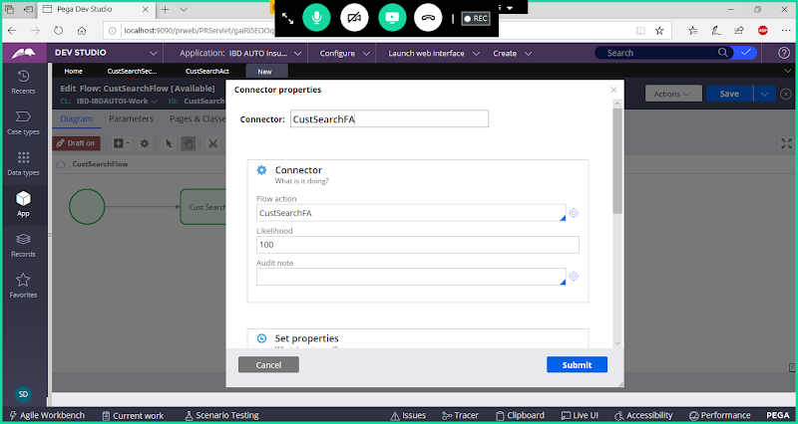

**Add Flowaction & Save Flow**

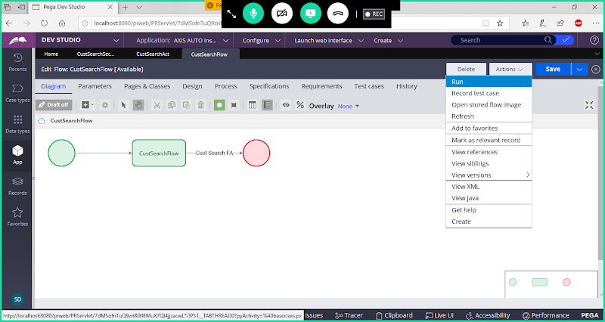

**Execute the Flow:**

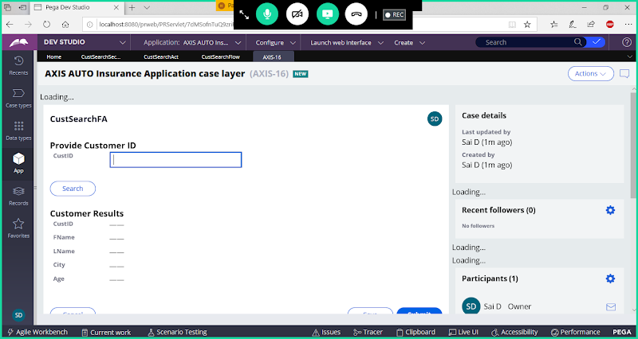

**Give Input ( CustID) & Click on Search Button**

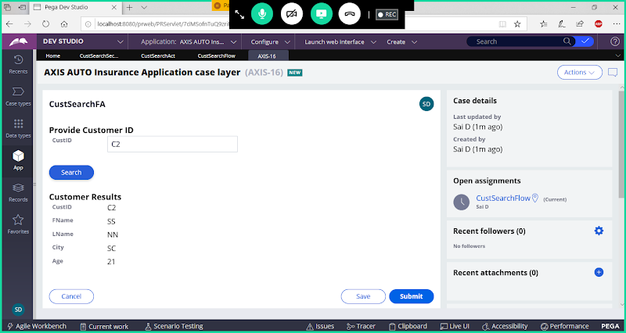

**Req2:**

**- When we load Customer Search form Only Display Input Property ( CustID with Search Button), If Input is Valid then only display Cust Results Page.**

**- If custID is not Valid then display error message CustID Doesn't exist.**

**How to identify in runtime Customer is available or not:**

**To Understand Customer existence in Database create a Flag Property:**

**Create A Flag Property:( Check Box) – CustExists ( Boolean)**

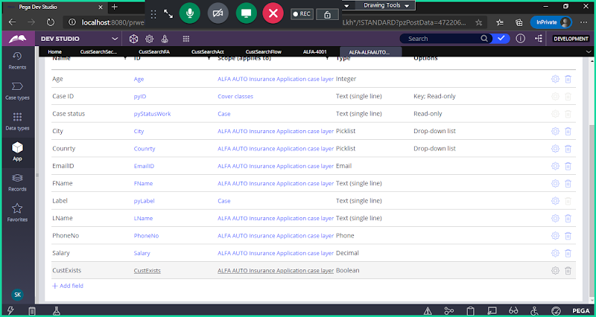

**Req: Redesign the section, to display customer results.**

**- Add Test/ label  Control From Basic Dropdown after search button**

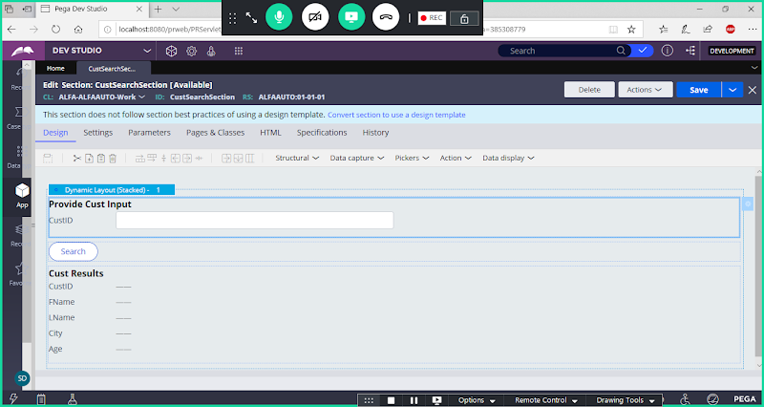

**Add Label Control from Data Display Dropdown, Add After Button Control**

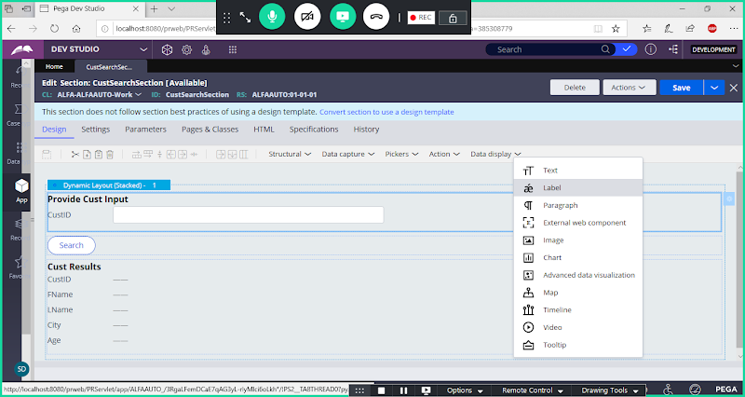

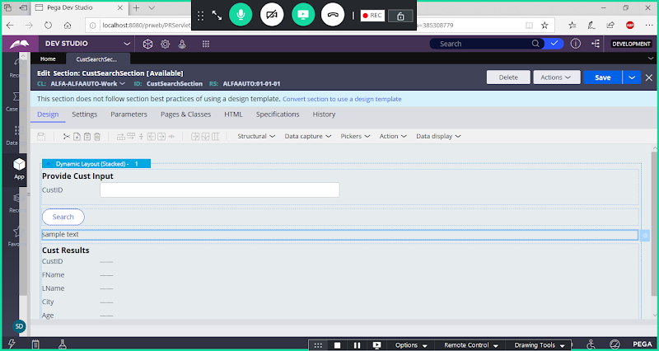

**Add Message in Label Settings**

**Double Click on Label settings:**

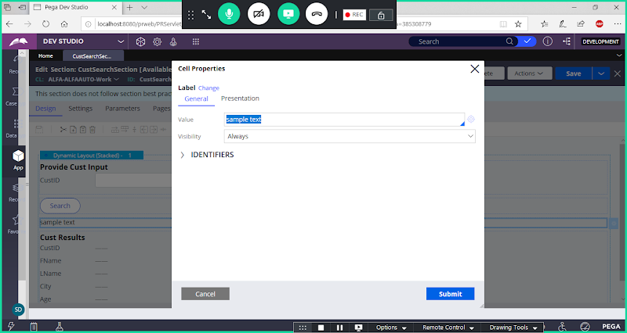

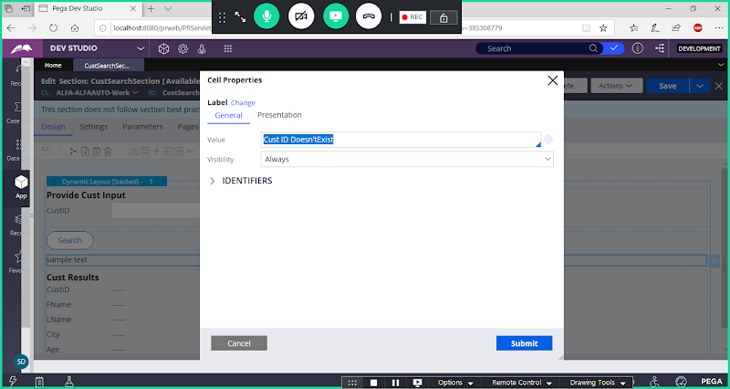

**Submit**

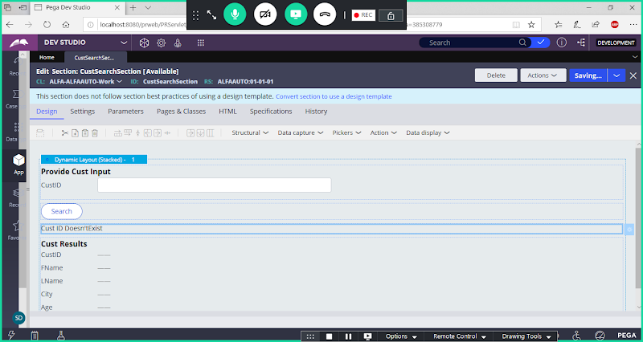

**Apply Visibility conditions for Customer search section based on CustExists Flag Property.**

**By Using Condition(Expression) add visibility conditions**

**If Customer is available : ( If CustExists = true)  then display Results ( Define this condition for CustResults Layout)**

**Double Click on CustResults Layout:**

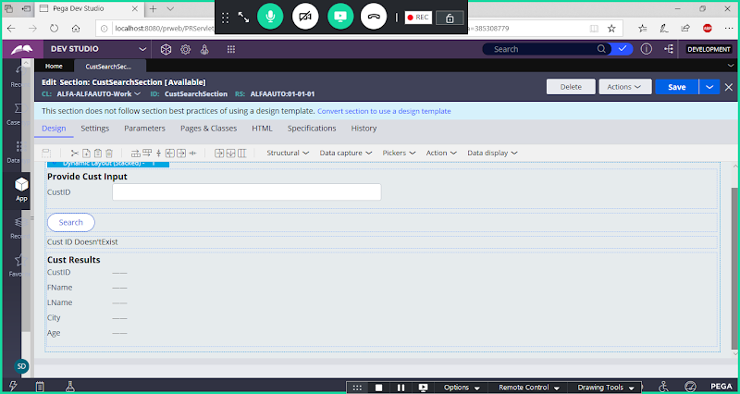

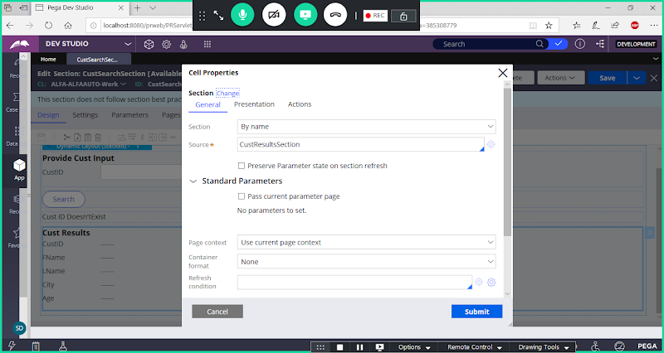

**Scroll Down**

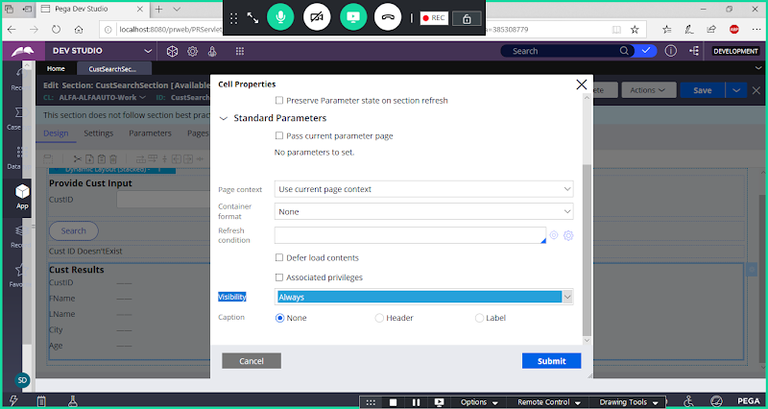

**Under Visibility Select Condition Expression:**

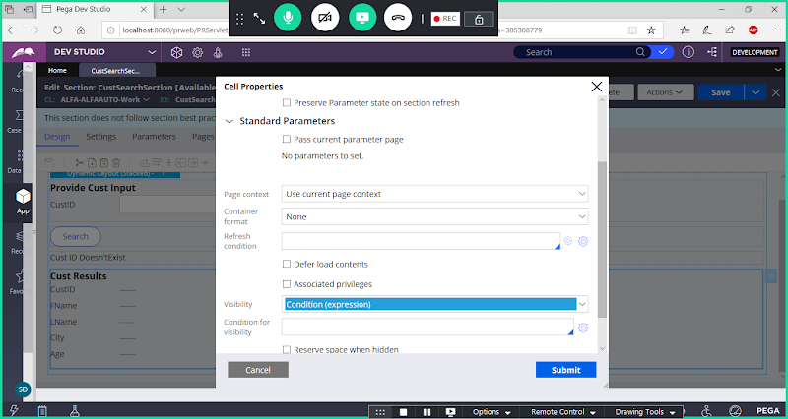

**Manually Add Condition:**

**.CustExists=="true"**

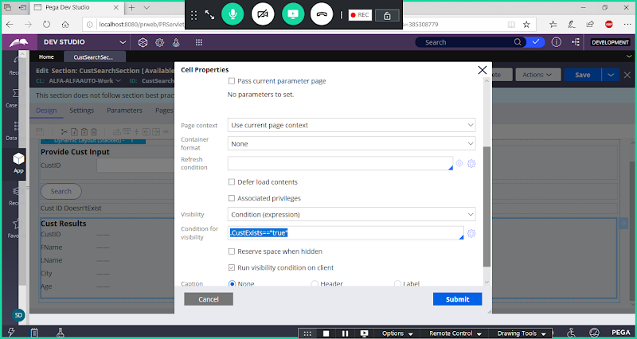

**Submit**

**If Customer is not available : ( If CustExists = false)  then display error message ( Define this condition for Label)**

**Double Click on Label:**

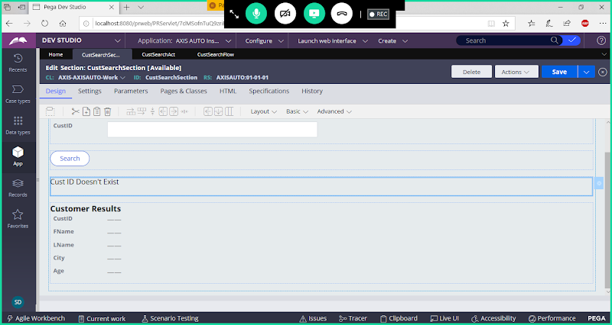

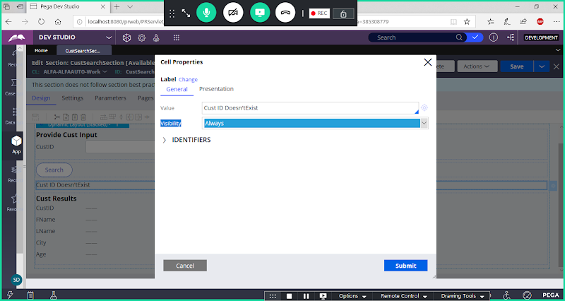

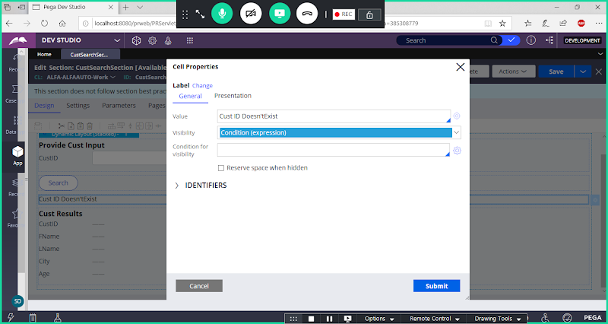

**.CustExists=="false"**

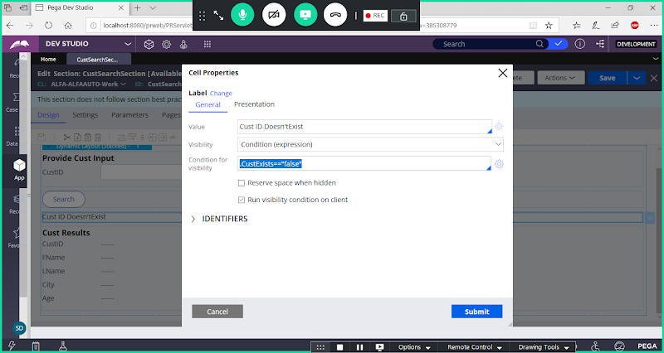

**Now Onload of Page By Default It will display the Label due to Run Visible condition on Client option.( Enable). We have to disable the Check box.**

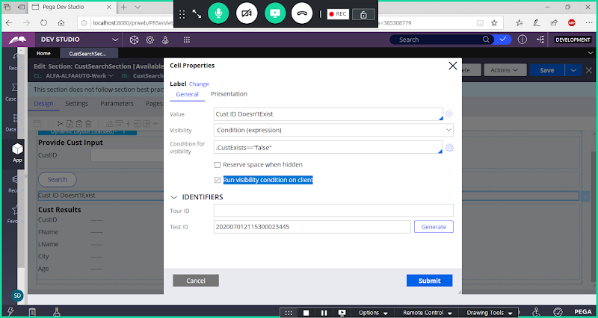

**Disable Run Visibility condition on Client:**

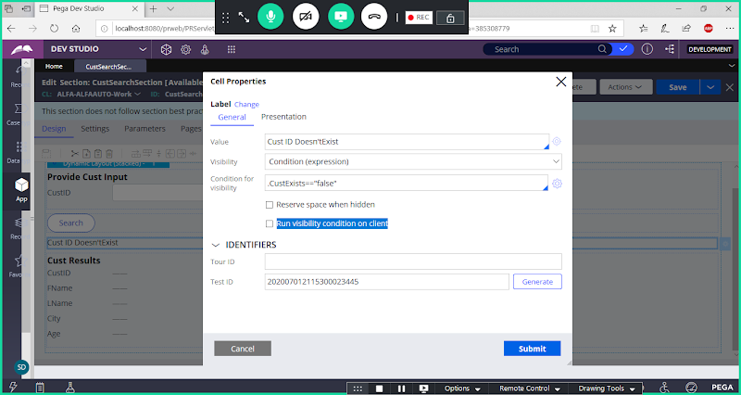

**Submit**

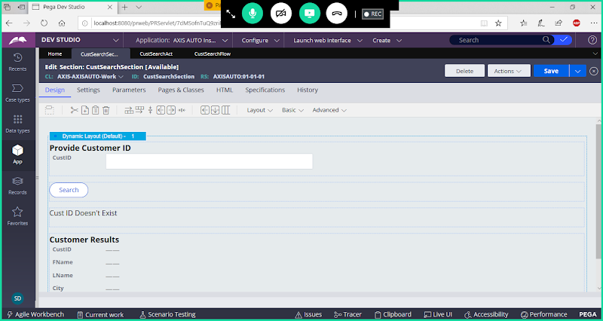

**Save Section & Check in**

**Open CustSearch Activity & Add changes:**

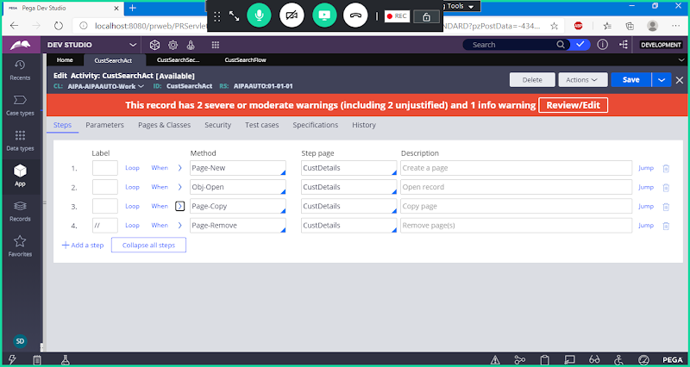

**Add New Step after Page new**

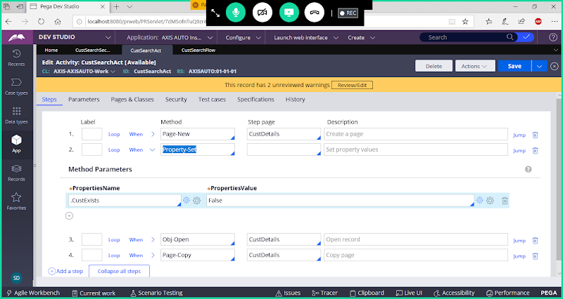

**Add Jump Condition for Obj-Open Method:**

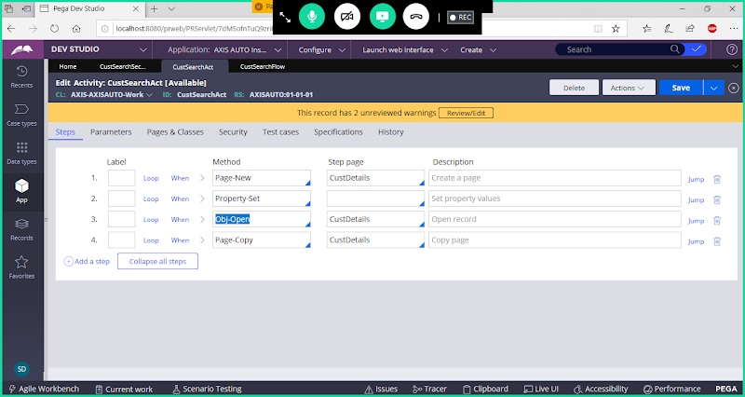

**Click on Jump**

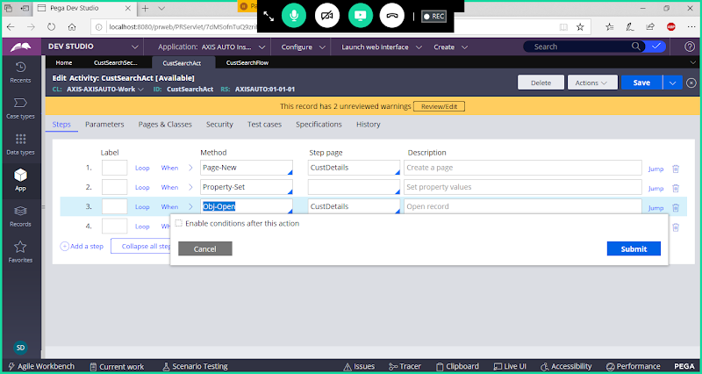

**Enable Condition**

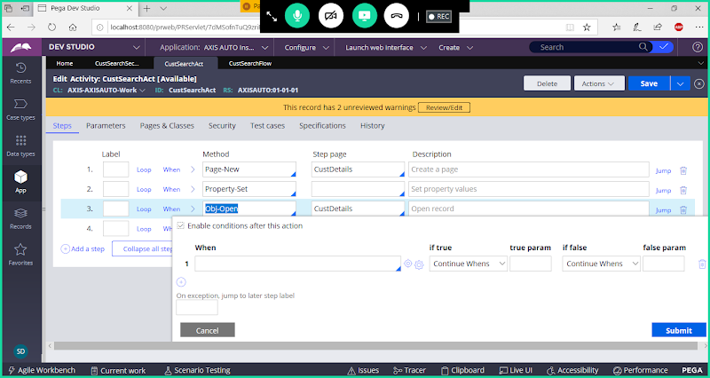

**Use Condition: StepStatusFail**

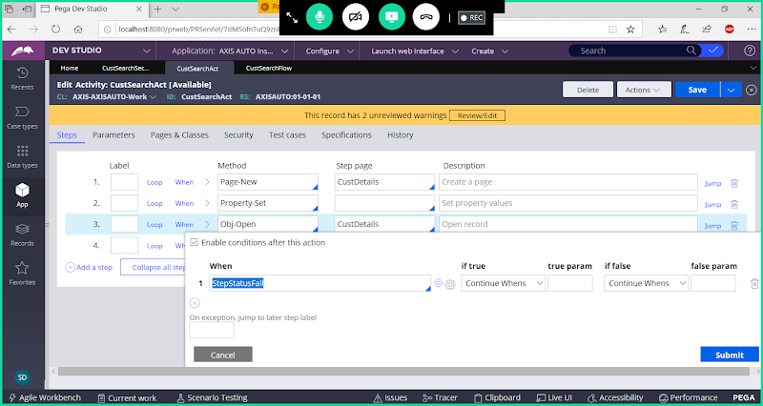

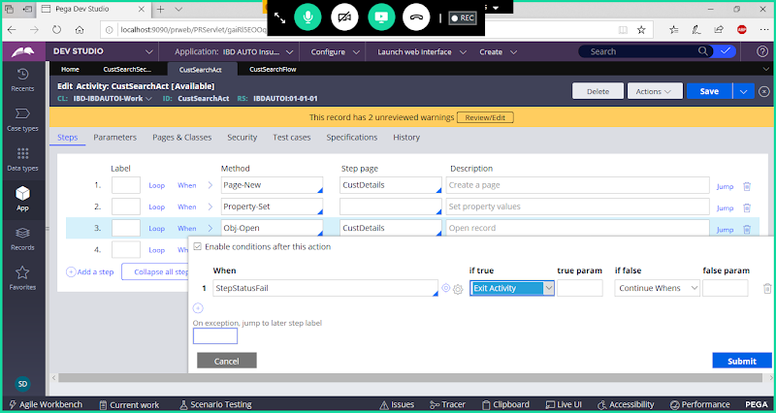

**Submit**

**After Obj-Open add Property set**

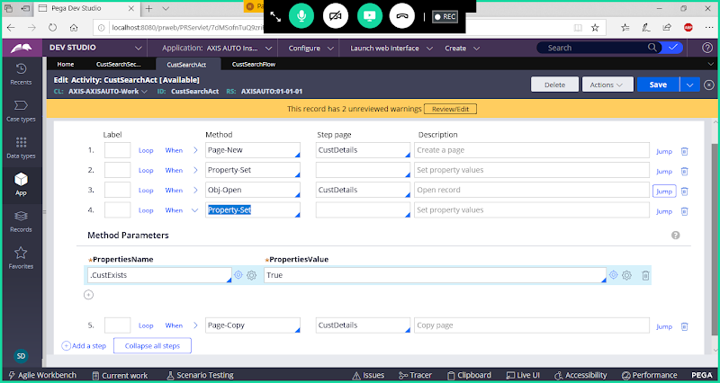

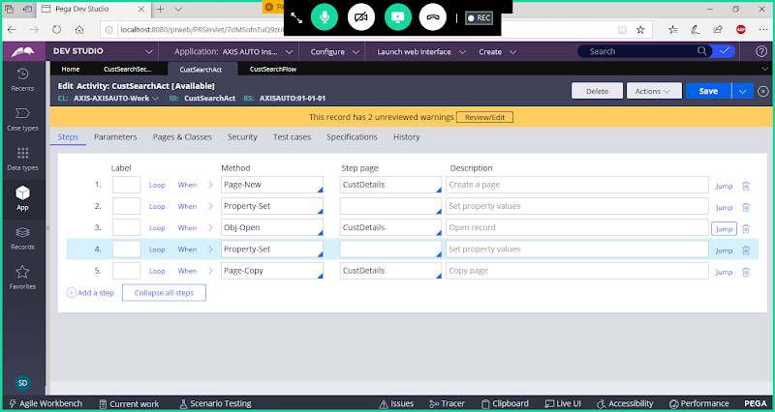

**Save Activity**

**Now Execute Flow**

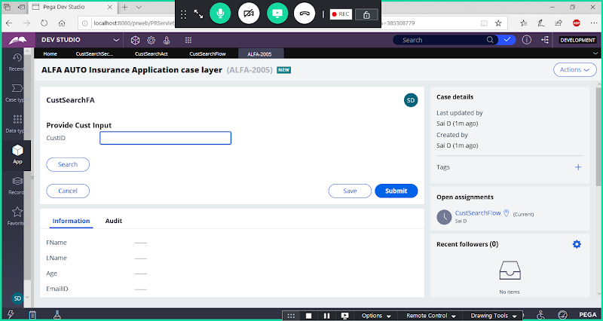

**Enter Valid CustID & Search**

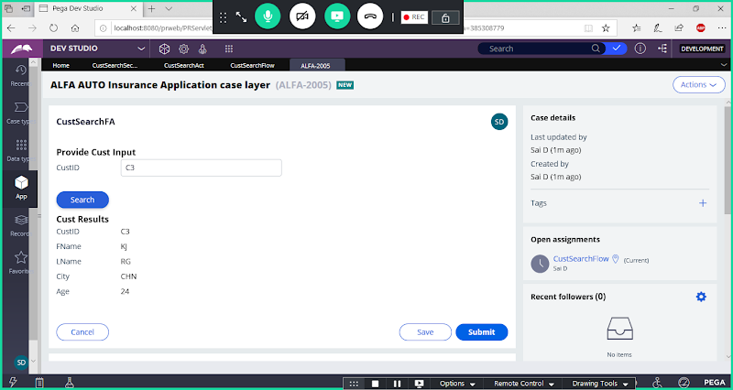

**Now Enter Invalid Cust ID**

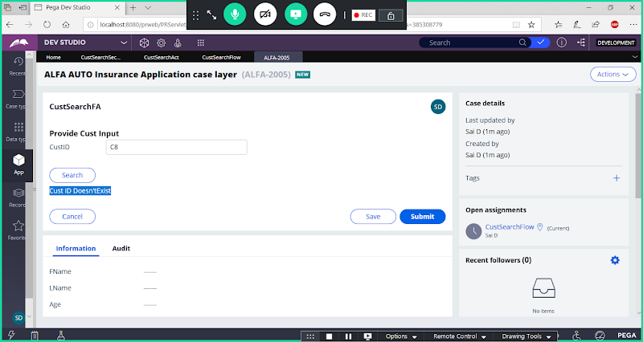

**===========**

**Task: Fetch Single Record based on CustID from Cust Table.  Try to display records in Separate Page**

**Start -------Ass1-----------Ass2-------End**

**Activity : Page -New,  Obj-0pen & Property -set**

**-------------------------**

**Temporary Work Objects in Flow.**

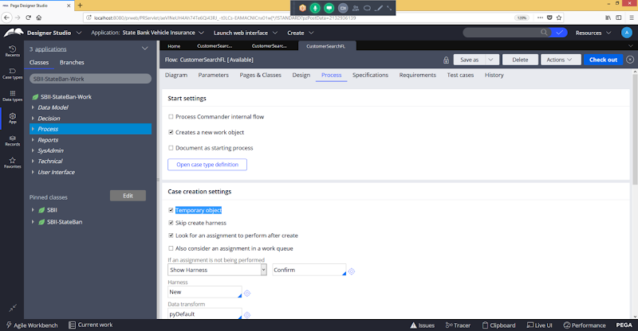

**When we choose Create temporary work object, PRPC will create a temporary case which will not have physical storage in the Work Table.**

**Temporary Work Object creation is useful for the transaction which has some set of validation to be done before saving the actual tractions or Case data into Work Table. A temporary WO can be converted into Permanent case by using a flow shape Persist Case.**

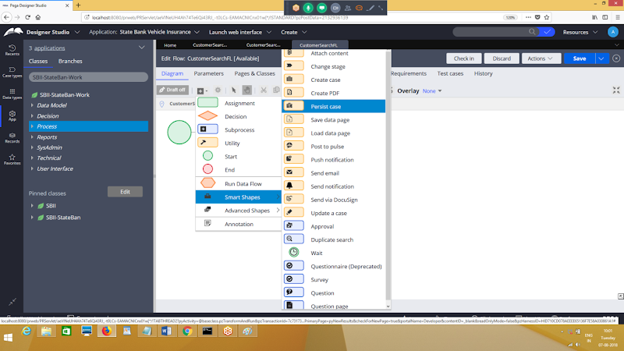

**Persist Case Flow Shape Converts a temporary case into a Permanent One.**